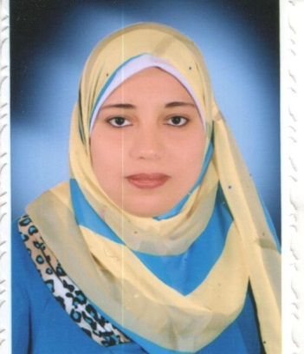**Abeer Abdelwares Mahmoud Abdelwares Address: Assiut- Elwalidia**

**Personal Information:**  **Date of Birth :** 6th April 1992

**Marital status:** Single

**Nationality:** Egyptian

**Email: -** abeer199246@yahoo.com

**Job:-**Demonsteator Aimal Medicine Deprtment Faculty of Veterinary Medicine - Assiut University

**Education & Qualifications :**

Bachelor of Veterinary Medical Science with honors in October 2014

**Skills:** **Languages- : Arabic :** Mother Tongue

**English:** Very Good written, spoken and Translation  **Computer- :** Keen user of the Internet.

\***Personal Skills :**

- Communication Skills . - Self confidence.

- Responsibility. - Perseverance.

- Team Work . - Setting Goals.

- Ability to work under pressure - Creative

- Cooperative

**FLDC certificates:**

Conference Organization (2014)

University Administration (2014)

Time and Conference Management (2015)

International Publishing of Research (2015)

Quality Standars in Teaching1 (2015)

How to CompeteaResearch Fund (2015)

**Certificates:**

English language Level one (2007)

English language Level Two (2007)

English language Level three (2008)--- ICDL (2013)

Presentation about Fractures of the bone in Horse (2012) from المؤتمر العلمى الخامس عشر

Participation from AVSSA (2012)

Training on End Note program me from مركز الخريجين كلية الطب البيطرى

**Hobbies:** Traveling, Reading, and Surfing Internet.

**References:** Academic and professional references are available on request.